Administrative Office
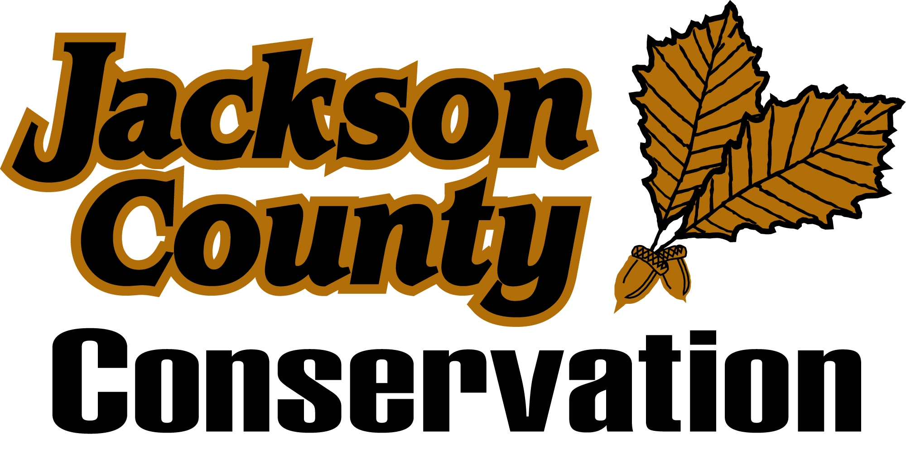
Hurstville Interpretive Center

BOARD MEMBERS
Randy Bender Bellevue 563/872-5953
Kathy Wosoba Monmouth 563/673-4551
Chris Cornelius Bellevue 563/672-3590
Larry McDevitt Maquoketa 319/541-6357
Dr. D.W. Yanda Maquoketa 563/652-2706

Mission Statement: The Jackson County Conservation Board is responsible to acquire, develop, maintain and make the following available to the inhabitants of the county: public museums, parks, preserves, parkways, playgrounds, recreational center, county forests, wildlife and other conservation areas, and to promote and preserve the health and general welfare of the people, to encourage the orderly development and conservation of natural resources, and to cultivate good citizenship by providing adequate programs of public recreations.

The Jackson County Conservation Board will meet in regular monthly session on Tuesday, March 10th,m 2015 at the Hurstville Interpretive Center, 18670 63rd St. Maquoketa. The meeting is scheduled to begin at 6:00 PM in the community room. The meeting is open to the public and a tentative agenda is as follows:

1. Call To Order

2. Approval of the Agenda

3. Approval of the minutes – February 17th Board meeting

4. Review and approve forest management contract – Kevin Oetken, Woodland Forestry.

5. Boat Dock Lottery Drawing – Spruce Creek Park harbor.

6. Park Management Update

A. Prairie Creek Recreation Area – Development Plan Update

B. Parks to People Strategic Plan Update

7. Other Business

A. Set April Board Meeting Date/Location

8. Visitor Input

9. Bills

10. Adjourn

