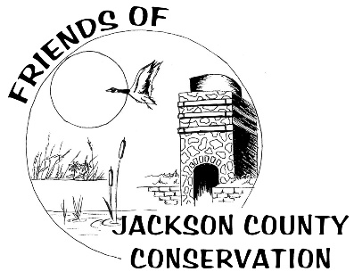

Quarterly Business Meeting Agenda

Tuesday October 11, 2016 at the Hurstville Interpretive Center
- 6:00 pm – Friends Board Meeting
- 6:30 pm – Potluck. Bring a dish to share; beverages and table service provided.
- 7:00 pm – Business Meeting

Agenda
- Call to Order
- Approval of Previous Meeting Minutes Sandy
- Treasurer’s Report Wendy

- Committee Reports (max 3 minutes each)
  - Bookkeeping Wendy/Alice
  - Membership Need a committee chair & members…
  - Gift Shop Wendy
  - Fundraisers Kathi
  - Programs/Events Staff
  - Bus Grants Jo Ellen
  - Prairie Creek Pavilion Jess

- Old Business (max 5 minutes each)
  - Birdies for Charity
  - Recruit committee members for Bookkeeping, Membership, Fundraising
  - Hurstville Marsh water pump
  - Friends sponsored events

- New Business (Discussion/Action items)
  - Prairie Creek Pavilion
  - Jackson County Area Tourism Association Membership

- Other Business
  - Elections (1 Friends Board Member)
  - Calendar – Next Meeting Tuesday, January 10, 2017 at the Hurstville Center

- Adjournment

